## use tf.keras.preprocessing.image_dataset_from_directory()

Have a folder in your pc to contain training images, each category will have a separate subfolder, like this:

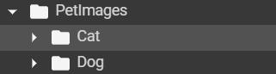

## then, in image_dataset_from_directory(), specify folder name, batch_size, image_size you want it to be, and two subsets of training and validation, haven't found how to build testing yet.

image_size = (180, 180)

batch_size = 32

train_ds = tf.keras.preprocessing.image_dataset_from_directory(

    "PetImages",

    validation_split=0.2,

    subset="training",

    seed=1337,

    image_size=image_size,

    batch_size=batch_size,

)

val_ds = tf.keras.preprocessing.image_dataset_from_directory(

    "PetImages",

    validation_split=0.2,

    subset="validation",

    seed=1337,

    image_size=image_size,

    batch_size=batch_size,

)